Congratulations on purchasing your new drum stand! Here is how to set it up!

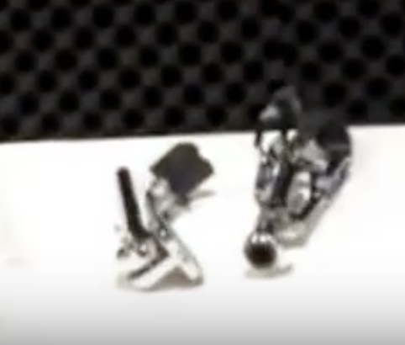These are the pieces you should have initially.

First, take the bottom piece out and loosen the bottom wingnut.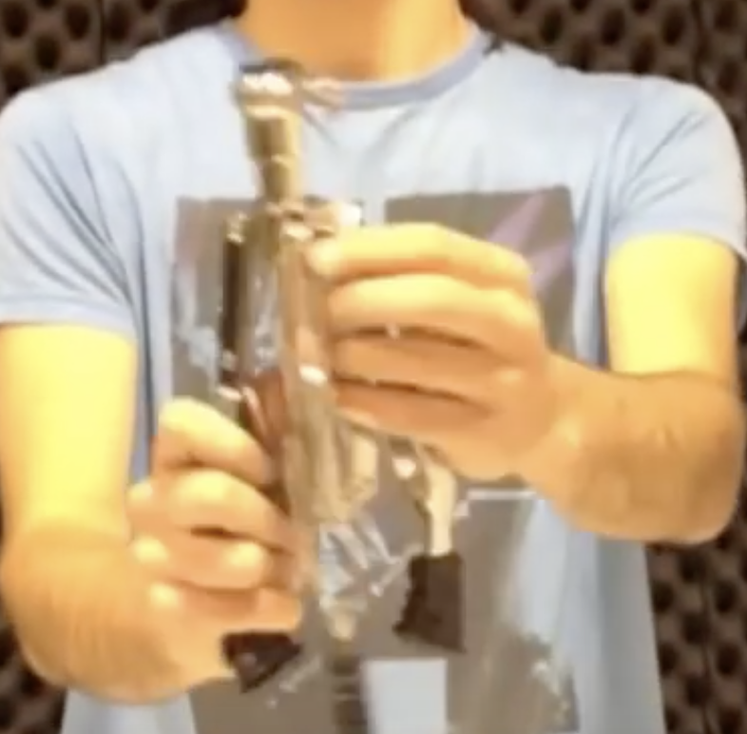

After doing this, you can push and pull the legs to make them speed less wider or wider respectively. Configure it to your liking depending on how much room you are willing to use up. Once you are done, re-tighten the wingnut. Then place the stand piece on the floor.

Next, take the other piece: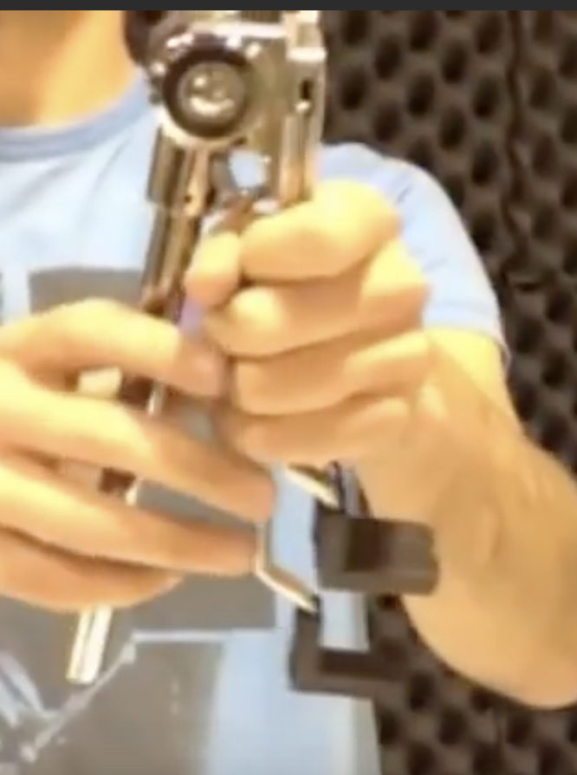and put it in the first piece: 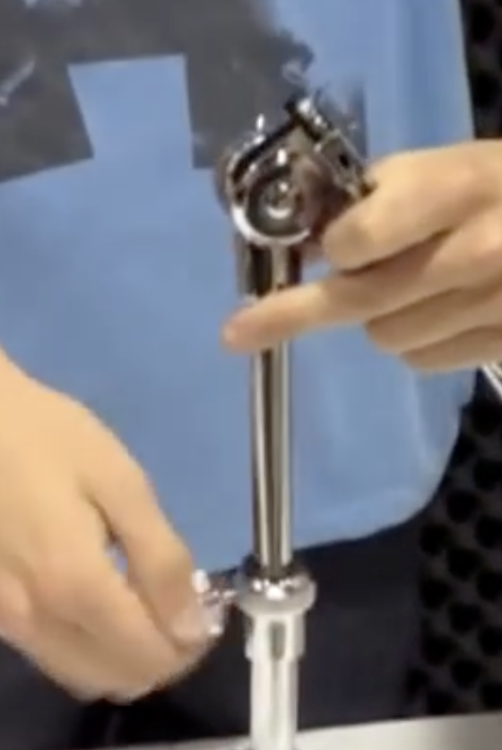and tighten the upper wingnut. If it was already tightened, loosen it before inserting the second piece, then tighten it after you insert the second piece.

On top of the second piece, there is the part that holds the snare drum:

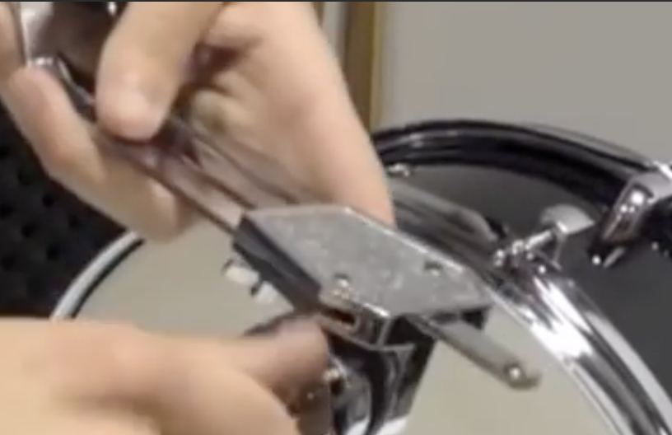You can move this up and down depending on what you want the angle of your snare drum should be.

Right below this is a wingnut. Tighten it.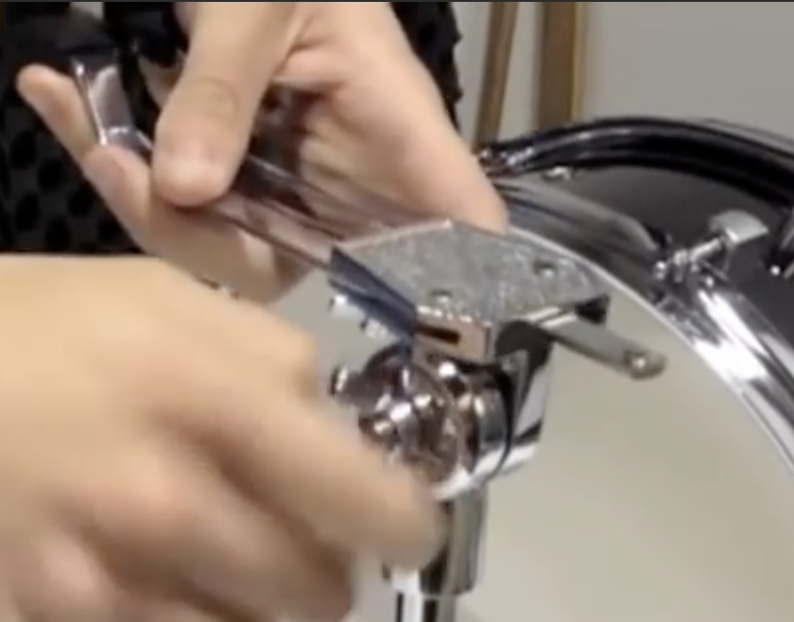

Next, spread the handles by pulling them: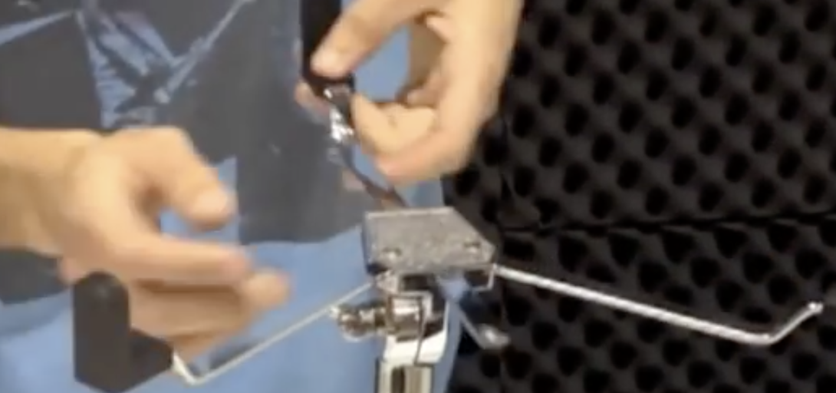Then tighten the screw from this photo: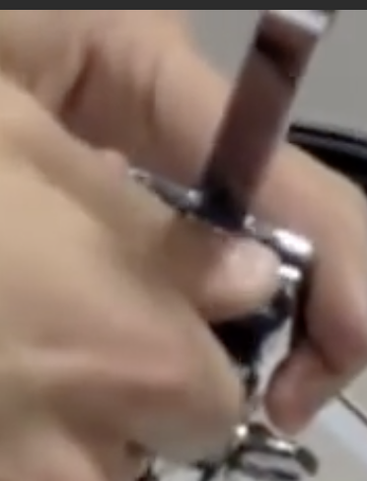

Place the snare drum between the handles as shown: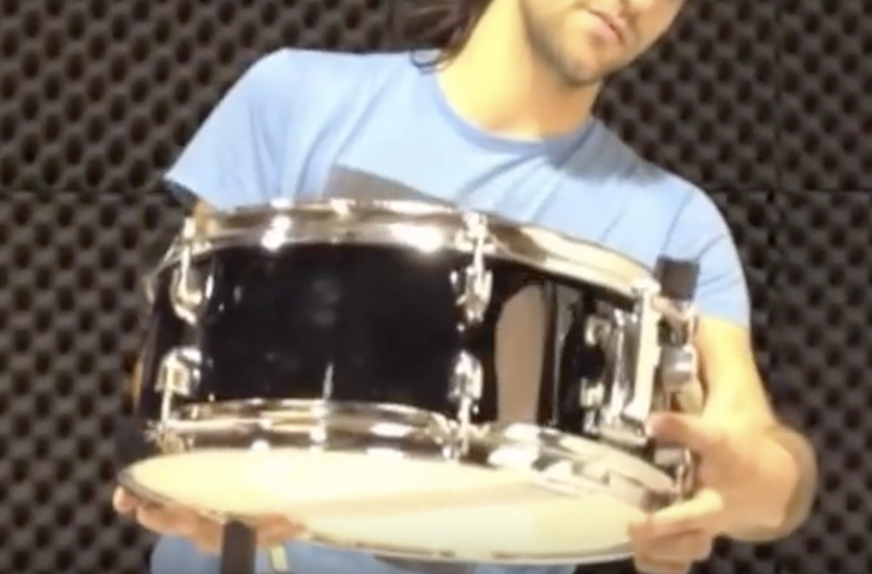To avoid damaging your snare drum, make sure it is on the rubber part of the handles, NOT the metal parts: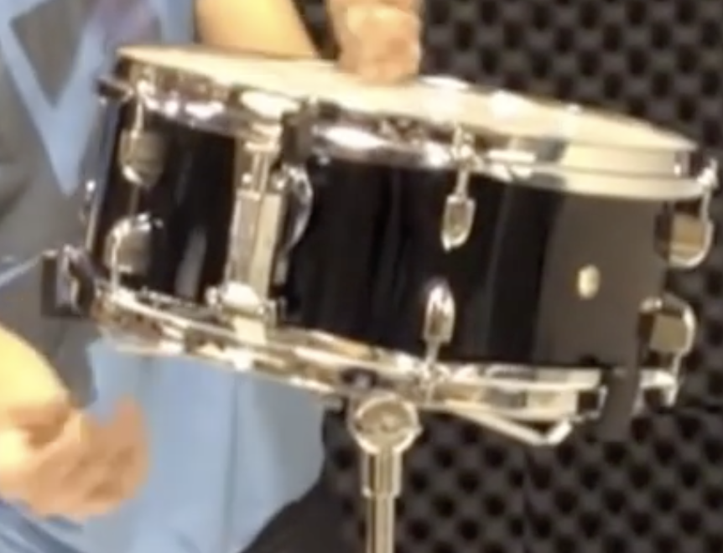

And that is how you setup a snare drum stand!